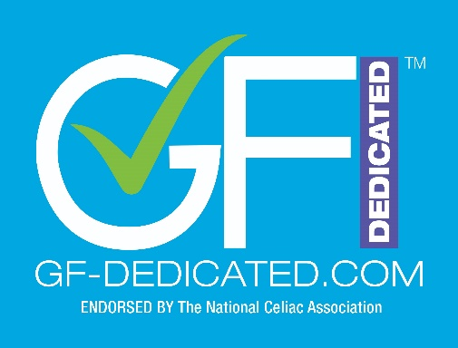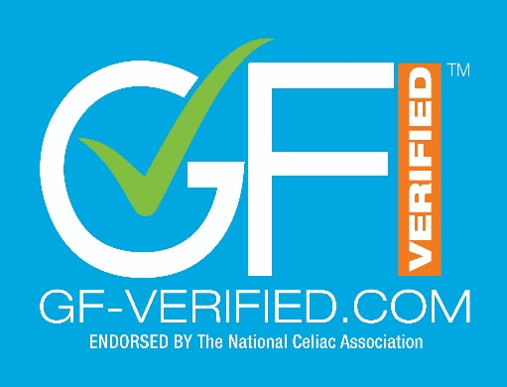

**Provides establishments** with the framework for consistent delivery of gluten-free food by providing training, standards, best operating practices and third-party verification audits. GFFP is the only certification program for the food service and hospitality sector that is endorsed by the National Celiac Association. We help committed operators grow their business by marketing their efforts to the gluten-free community.

**Provides the consumers** with easily identifiable and recognizable brand marks. GFFP USA Inc helps consumers find safer, more reliable gluten-free options when dining out.

To find trusted establishments visit:

[www.gf-finder.com](http://www.gf-finder.com)

To lean how your establishment can become GFFP USA Certified visit our website [www.gf-verified.com](http://www.gf-verified.com) or fill out the online application/information form found here: <http://gf-verified.com/industry/gffp-application_us/>

For more details contact Jacquie Peppler:

1-888-902-5104 ext.102 [jacquie.peppler@glutenfreefoodprogram.com](mailto:jacquie.peppler@glutenfreefoodprogram.com)

Andrew Batten:

1-888-902-5104 ext.101

[andrew.batten@glutenfreefoodprogram.com](mailto:andrew.batten@glutenfreefoodprogram.com)

Gluten-Free Food Program